Bridgepoint Parts Catalog

Section XXXIV: Rotary Drimaster Parts Page 1

PHY169-058 Valve – Hydramaster SS

Wand / RX-20/ RDM

Repair Parts:
Stem Assembly: PHY012-002
O-ring Kit: 100012
Cap: PHY027-001
Spring: PHY155-003

PHY061-004

Foam Grip – Handle

Closed End

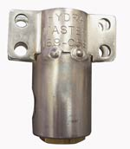
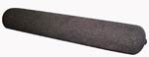

AX32

Power Cord 12/3 x 25’

Male & Female Ends
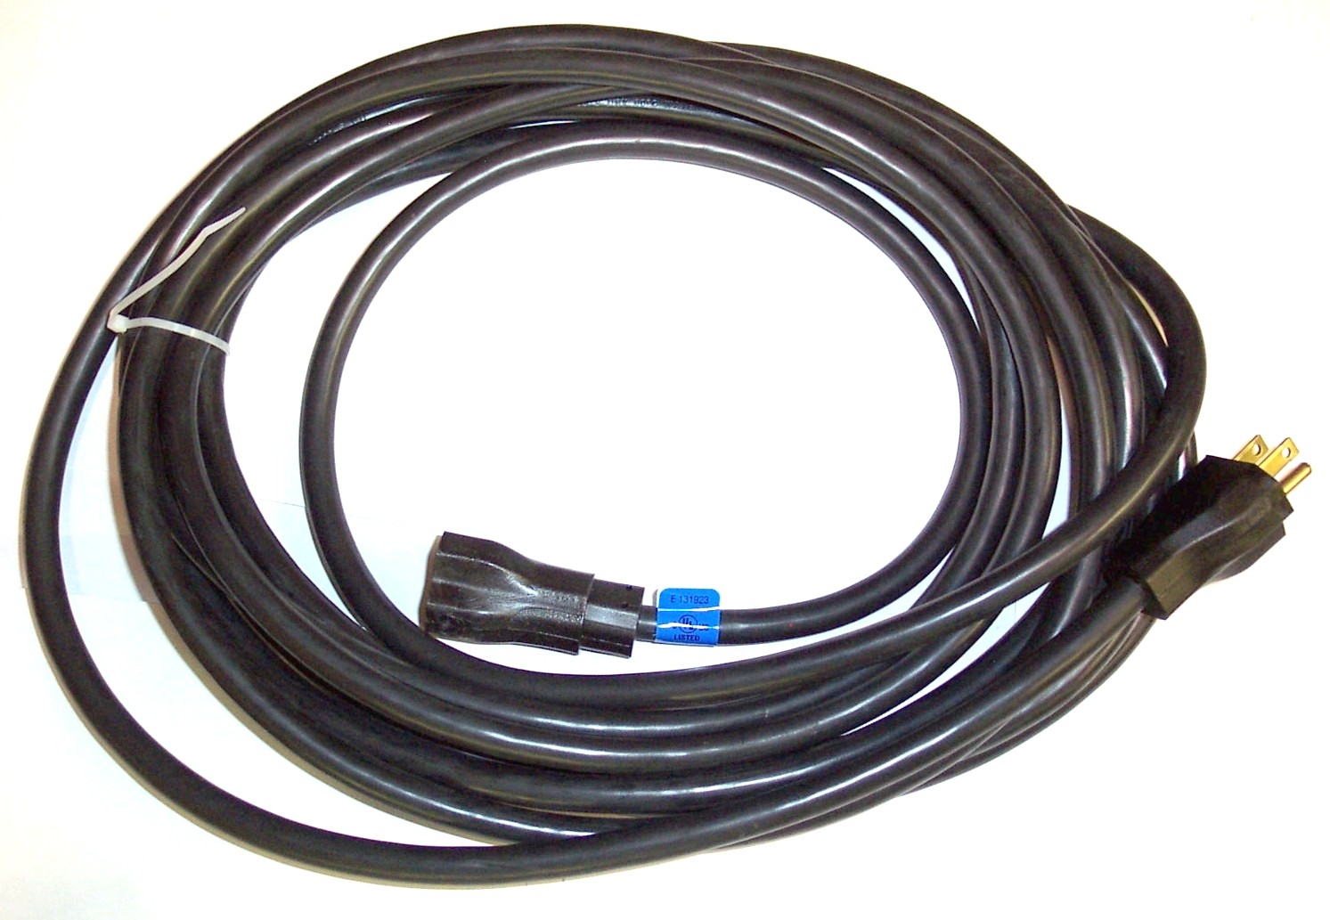

PHY154-001

Spacer 1/4” X 5/16” SS

Valve Mounting

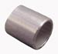

AX33

Power Cord 12/3 x 50’

Male & Female Ends

PHY167-009

Trigger – RDM Solution Valve

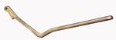

NM5038

Strain Relief – Cord Grip

Black Plastic
Hydramaster part # 108-012

Replacement back-up nut: NM5039

PHY167-010

Trigger – RX-20 Power Switch
Pivot: PHY107-103

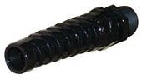
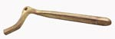

BR126

Fitting 1/4” MPT x 1/4” Flare
(Hydramaster Part # 057-527)

PGR01

Strain Relief – Metal-Wire Mesh

Power Cord Grip

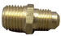
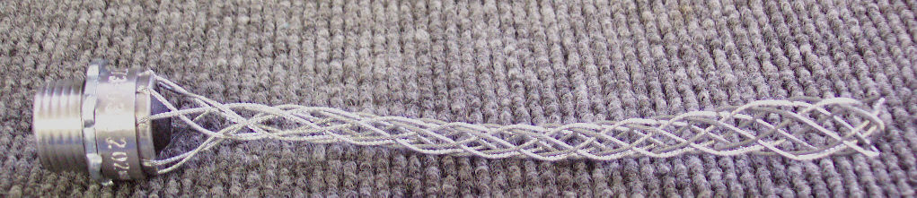

PA065

Y-Strainer 1/4” FPT

Replacement Filter Screen: PHY049-016

PHY157-032

Microswitch – RX-20 Power
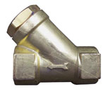
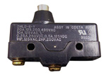
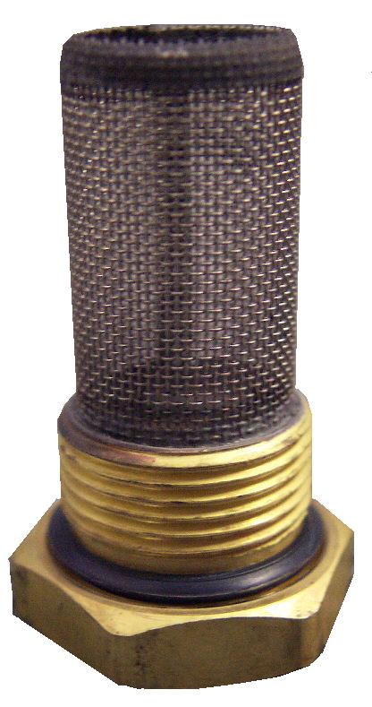

PHY108-014

Shield – RX-20 Microswitch

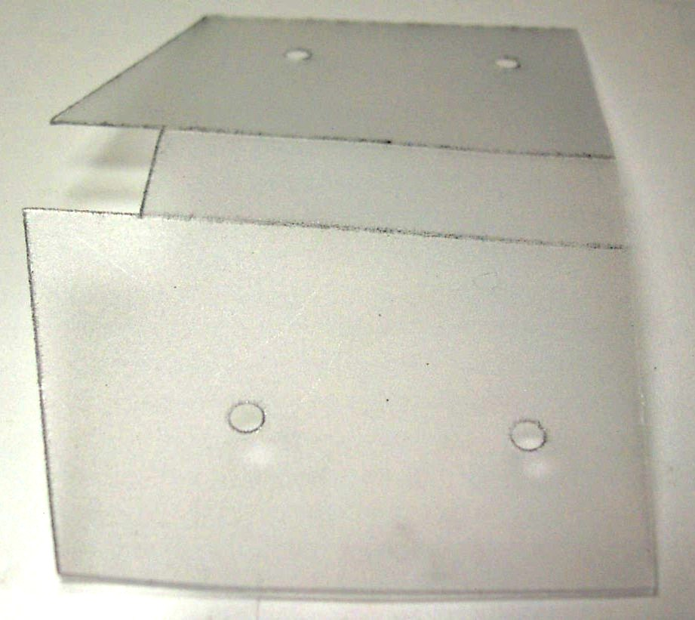

100009

1/4” Male Quick Connect

Brass
(Hydramaster part #052-050)

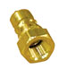

PHY052-423

Bushing – Modified

Orifice Housing
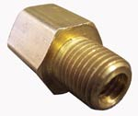

BR072

1/4” Hex Nipple – Brass
(Hydramaster Part # 052-071)

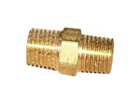

BR282

Elbow 90° 1/4” Street – Brass
(Hydramaster Part # 052-085)

PHY180-006

Orifice 0.061” – Set Screw

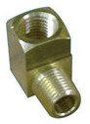
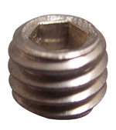

BR080

1/8” Close Nipple – Brass
(Hydramaster Part # 052-072)

BR304

Fitting 1/8”MPT x 1/4” Compression
(Hydramaster Part #052-714)
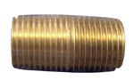
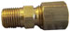

Bridgepoint Parts Catalog

Section XXXIV: Rotary Drimaster Parts Page 2

PHY041-013

Access Cover - Handle

PHY143-166

Screw 10-24 x 3/8” SS HHC

PHY143-559

Screw 6-32 x 0.56” SS FHDP

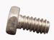
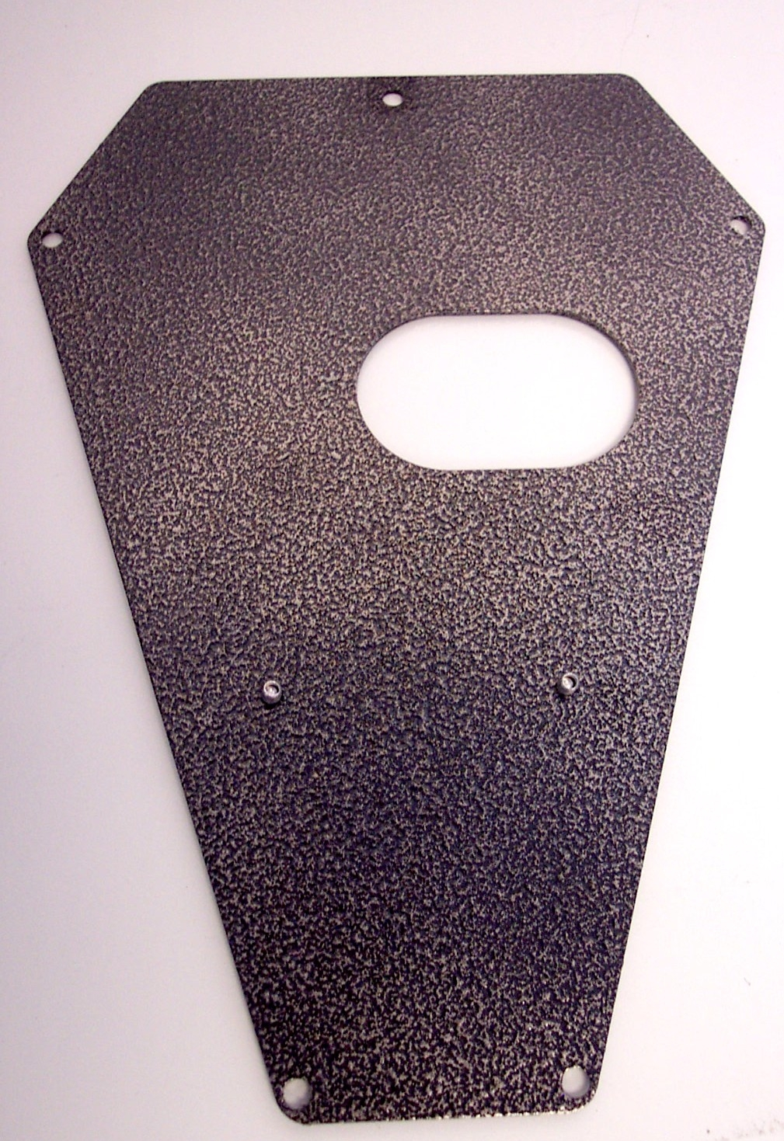

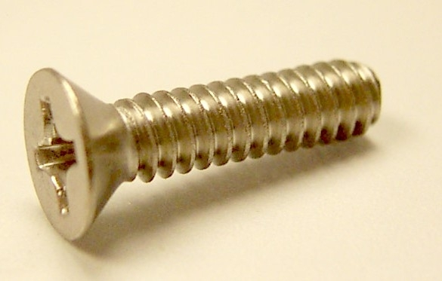

PHY143-113

Screw 10-24 x 1.50” SS FHDP

PHY143-560

Screw 10-24 x 1.63” SS FHDP

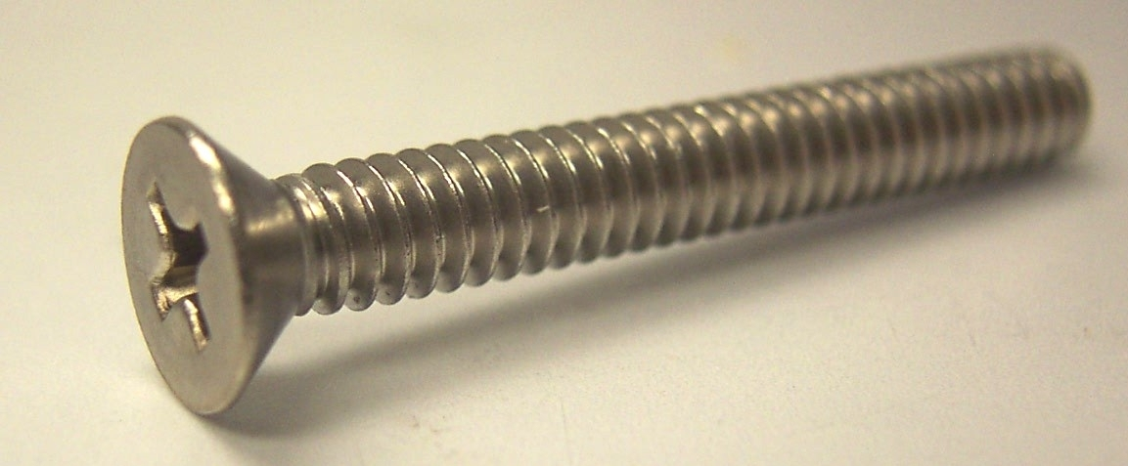

PHY010-116

RDM Timing Belt - Small

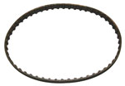

PHY010-117

RDM Timing Belt - Large

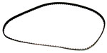

PHY139-009

Snap Ring 1/2” E-Clip

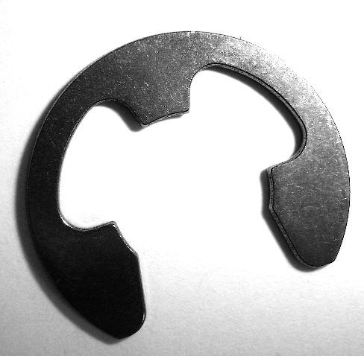

PHY041-403

Cover RDM Vacuum – Clear
Comes with Handle End Gasket
(Hydramaster part #041-413)

Gasket – Handle End: PHY057-185
Gasket – Head End: PHY057-053
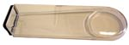

PHY155-055

Spring – Torsion Idler

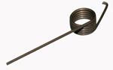

PHY008-050

Bearing – Reduction Gear

PHY076-069

Jet Bar SS – RDM

Gasket: PHY057-183

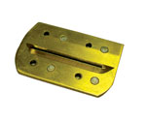

PP43-810012

O-ring 1/4” ID x 3/8” OD
(Hydramaster Part #097-066)

PHY108-129

Protector – RDM Jet Bar

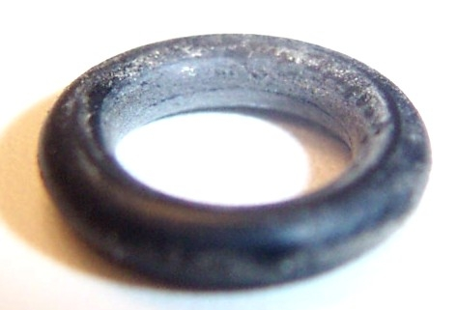

PHY154-135

Stabilizer Pad - RDM

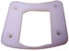

PHY052-719

Elbow 90°1/8” FPT x 1/4” Compression

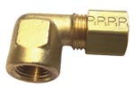

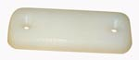

PHY147-064

Seal 3” x 1-1/4” Nylon

RDM Vacuum

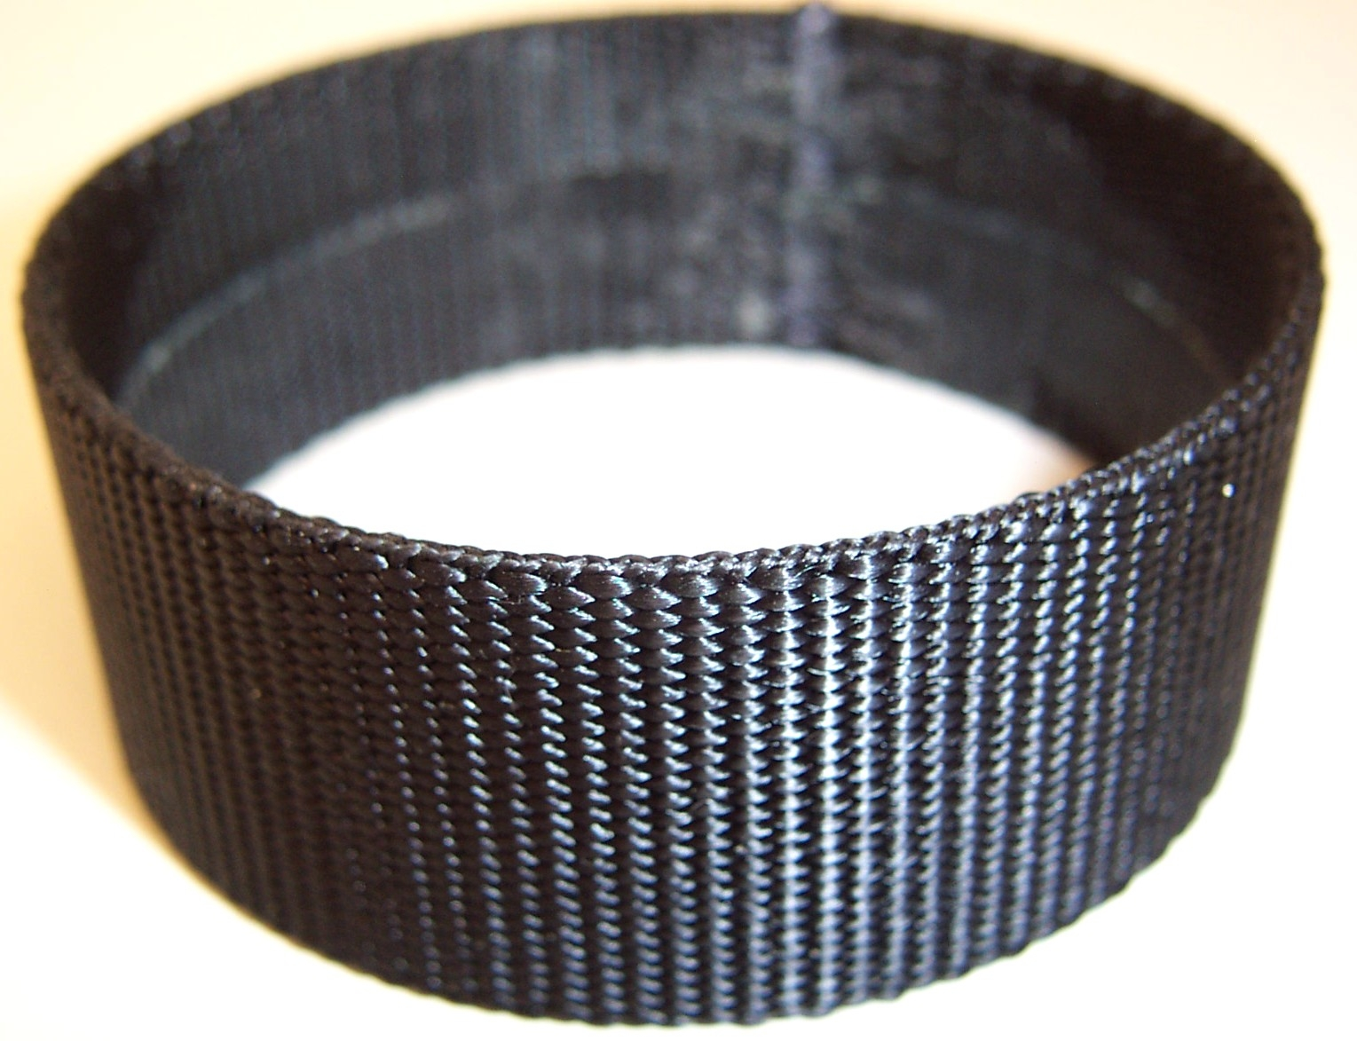

PHY041-414

Cowling RDM Top Cover

PHY041-412

Cowling RDM Bottom Cover

